**Project & Investment Risk Analysis**

**Alternative Measures of Risk**

# Variance

* Average of the squared deviations around the mean
* **Symmetrical Measure** → Accounts for deviations **both above and below** the mean





# Semi-Variance

* Investors are typically worried only if their **investment underperforms** thus they are more worried about the **downside risk**
* Average of the squared deviations **strictly above OR below** the mean (**Asymmetrical Measure**)





* 
* 
* 

## Interesting Properties

* Variance measures both Upside and Downside risk while semi-variance is just one of the two
  + 
* *F*or a **symmetrical distribution** (Normal & Uniform), the Upside and Downside Variance are **equal**
  + 
  + 

# Value at Risk (VaR)

* 
  + 
  + 
  + 
* Interpretation of VAR:
  + 
  + 
  + VaR quantifies the potential Gains or Losses at a specific level







* 

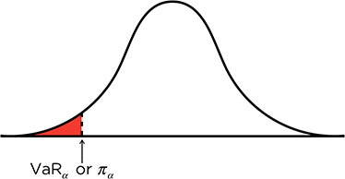

# Tail Value at Risk

* Extension of VAR which quantifies the potential losses *worse* than the specified level
* It is the **conditional expectation** of the distribution, given that the variable is at the VaR tail
* Thus, it is also known as the **Conditional Tail Expectation (CTE)**









* 
* 

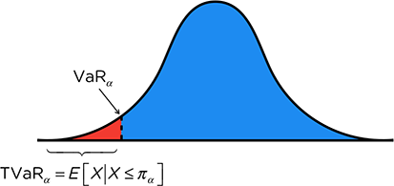

Note that for both VaR and TVaR, the diagrams above both assume that the distribution are measuring *gains* - if it were for *losses*, then the **tails would be on the other side, changing the formulas and interpretations**

# Coherence

* There are 4 desirable characteristics for a risk measure
* If a risk measure achieves these 4 targets, then the measure is said to be **Coherent**

|  |  |  |
| --- | --- | --- |
| Name | Expression | Intuition |
| **Translation Invariance** |  | Increasing the risk **increases the risk measure** too |
| **Homogeneity** |  | Scaling the risk **scales the risk measure** too |
| **Subadditivity** |  | Risk Measure **reflects diversification benefits** |
| **Monotonicity** |  | Risk Measure **orders the risk identically** |

|  |  |  |  |  |
| --- | --- | --- | --- | --- |
|  | **Variance** | **Semi-Variance** | **Value at Risk** | **Tail Value at Risk** |
| **Translation Invariance** | No | No | Yes | Yes |
| **Homogeneity** | No | No | Yes | Yes |
| **Subadditivity** | No | No | No  Yes if symmetric | Yes |
| **Monotonicity** | No | No | Yes | Yes |